Create a Virtual Machine with 1 CPU, 2GB RAM and 15GB storage disk using a Type 2 Virtualization Software.

Procedure:

Step1: Creating a virtual machine with type 2 Virtualization software

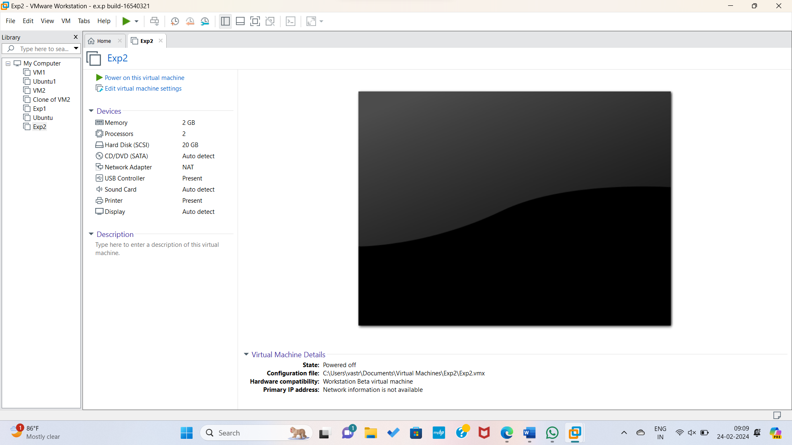

Step2: Changing the parameters in above fig as mentioned in question.

Step3: Inserting new hard disk.

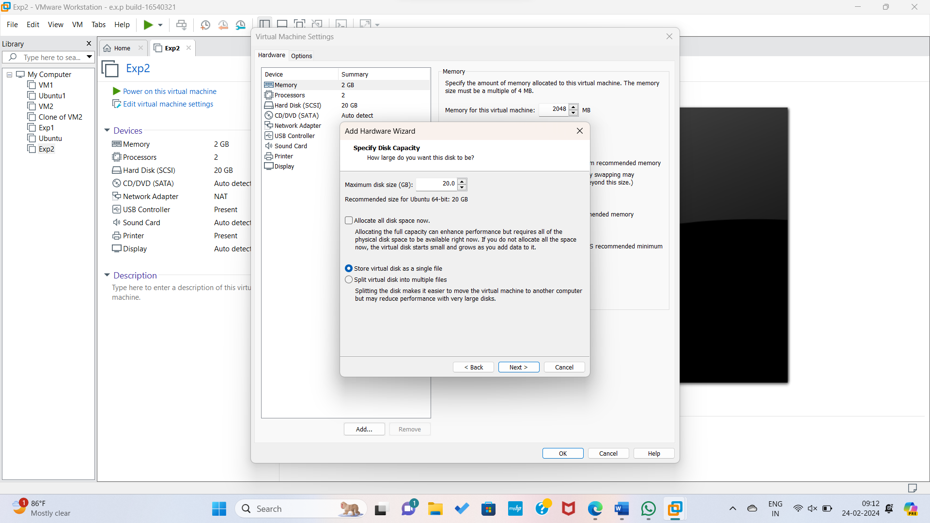

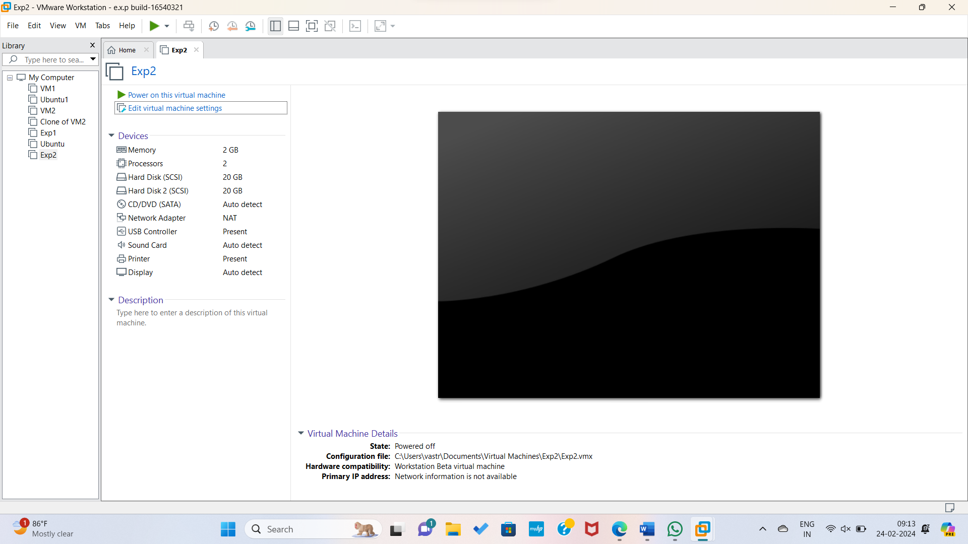

Step4: Changing parameters.

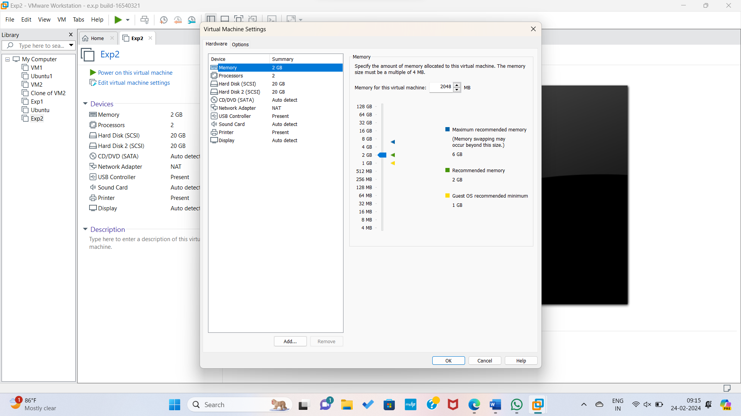

Step5: Changing CPU Memory Parameter.

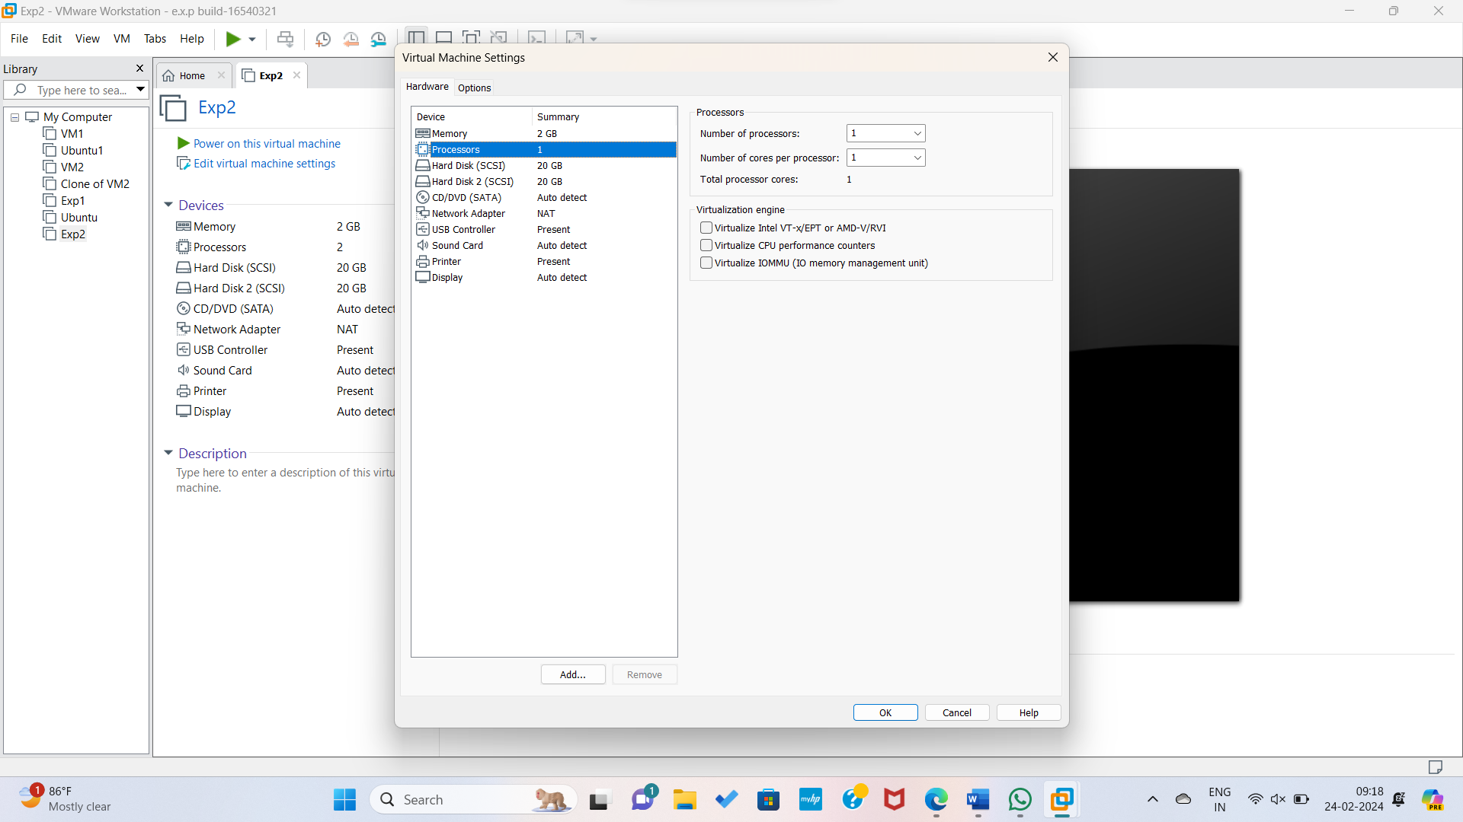

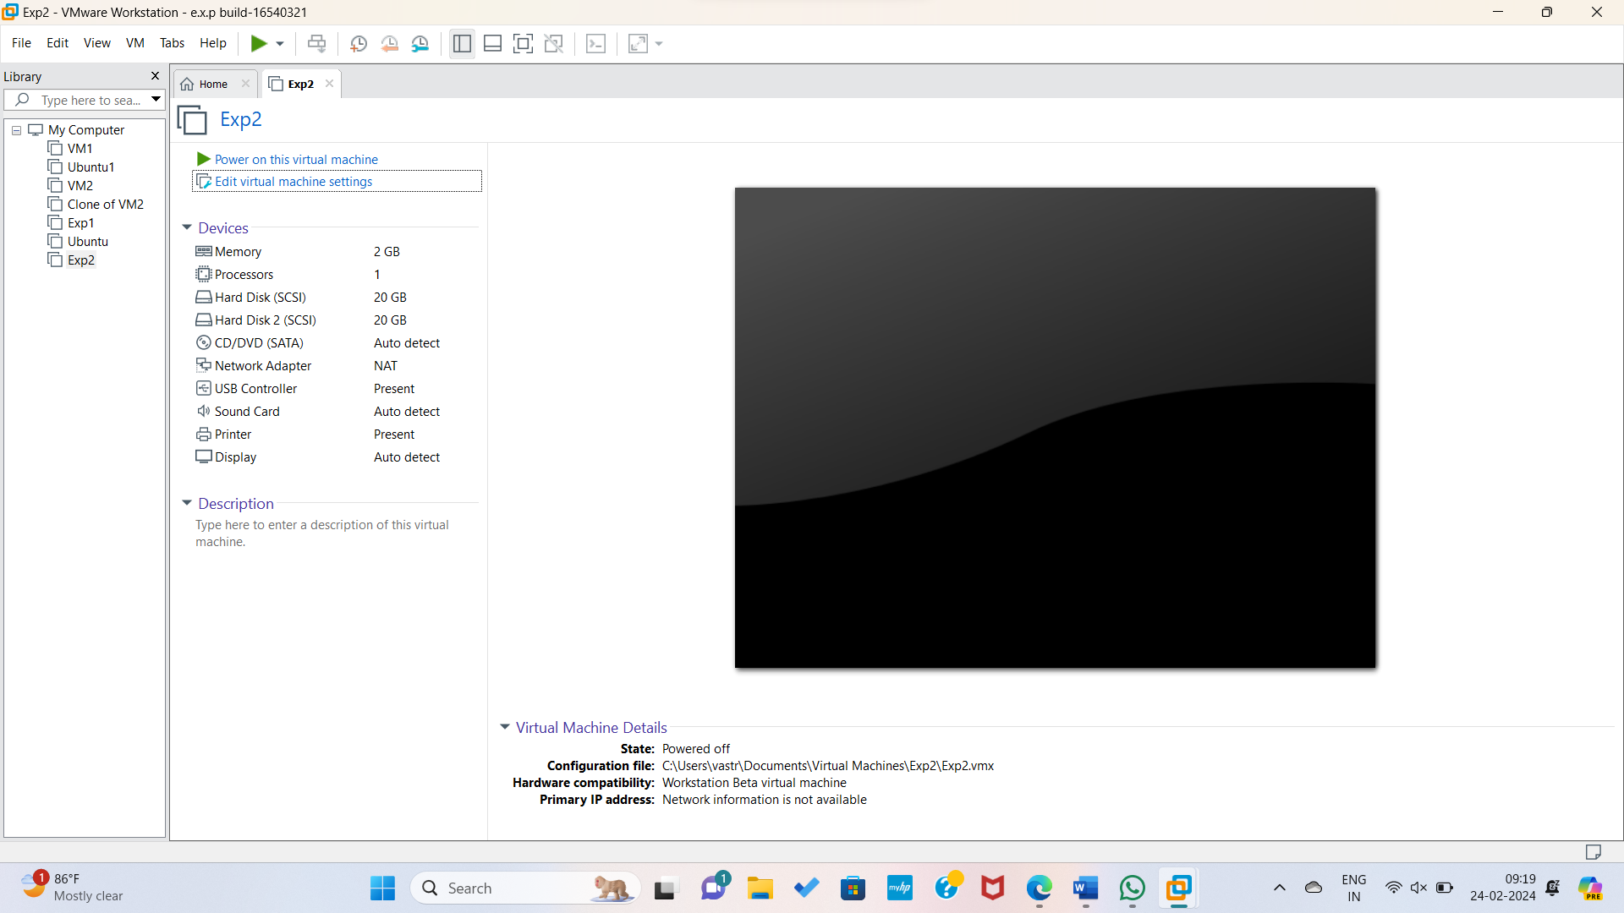

Step7: Hence all the parameters added Successfully.

